UNIT -1

OPERATING SYSTEM OVERVIEW

Operating System:
A program that acts as an intermediary between a user of a computer and the computer hardware.
Operating system goals:
- Execute user programs and make solving user problems easier
- Make the computer system convenient to use
- Use the computer hardware in an efficient manner

An operating system (OS) is system software that manages computer hardware, software resources, and provides common services for computer programs. Time-sharing operating systems schedule tasks for efficient use of the system and may also include accounting software for cost allocation of processor time, mass storage, printing, and other resources.

For hardware functions such as input and output and memory allocation, the operating system acts as an intermediary between programs and the computer hardware, although the application code is usually executed directly by the hardware and frequently makes system calls to an OS function or is interrupted by it. Operating systems are found on many devices that contain a computer from cellular phones and video game consoles to web servers and super computers.

The dominant general-purpose desktop operating system is Microsoft Windows with a market share of around. MAC OS by Apple Inc. is in second place, and the varieties of Linux are collectively in third place. In the mobile sector (including smart phones and tablets), Android's share is up to in the year 2020. According to third quarter 2016 data, Android's share on smart phones is dominant with 87.5 percent with also a growth rate of 10.3 percent per year, followed by Apple's IOS with 12.1 percent with per year decrease in market share of 5.2 percent, while other operating systems amount to just percent. Linux distributions are dominant in the server and supercomputing sectors. Other specialized classes of operating systems (special-purpose operating systems), such as embedded and real-time systems, exist for many applications. Security-focused operating systems also exist. Some operating systems have low system requirements (e.g. light-weight Linux distribution). Others may have higher system requirements.

Some operating systems require installation or may come pre-installed with purchased computers (OEM-installation), whereas others may run directly from media (i.e. live CD) or flash memory (i.e. USB stick).

Operating system objectives

An operating system is a program that acts as an intermediate part between a user of a computer and the computer hardware and controls the execution of all kinds of programs. An operating system is the program that, after being initially loaded into the computer by a boot program, manages all the other programs in a computer.

Objectives of OS:

1.Convenience: An OS makes a computer more convenient to use.

2.Efficiency: An OS allows the computer system resources to be used in an efficient manner.

3.Ability to evolve: An OS should be constructed in such a way as to permit the effective development, testing, and introduction of new system functions without interfering with service.

Computer System Structure

Computer system can be divided into four components

- Hardware: provides basic computing resources CPU, memory, I/O devices
- Operating system: Controls and coordinates use of hardware among various applications and users
- Application programs: define the ways in which the system resources are used to solve the computing problems of the users Word processors, compilers, web browsers, database systems, video games
- Users: People, machines, other computers

Four Components of a Computer System

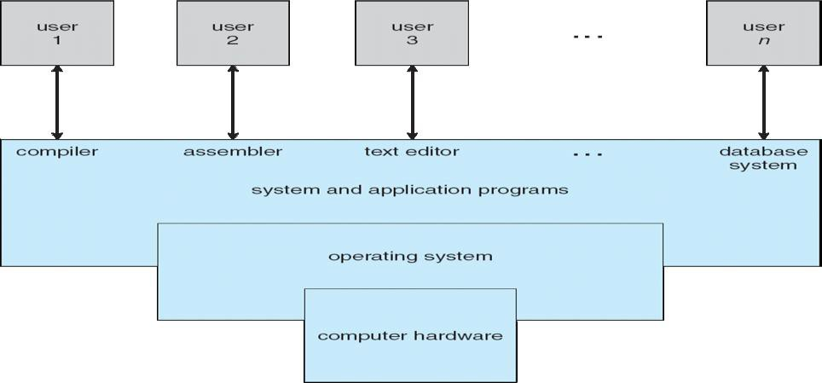

The operating system provides a proper means to utilize the resources of the computer system. It provides an environment within which other programs can do useful work. To understand the operating system clearly, it is explored with two viewpoints.

User View – The goal of the operating system in this viewpoint is to maximize the work (or play) that the user is performing. Therefore in this viewpoint, the operating system is designed for ease of use of the system for the user. And less attention is paid to the performance of the operating system.

System View – The goal of the operating system in this viewpoint is to maximize the performance. In this viewpoint, the operating system is more involved with hardware services – CPU time, memory space, I/O operation, and so on. The operating system is involved in managing the hardware resources and allocation them to programs and users for maximum performance.

The computer system can be categorized mainly in four components – hardware, operating system, application program, and the user. The hardware is responsible for providing various resources such as memory and register or processing whenever the operating system demands and the operating system will only demand when the application programs that are developed by the software engineer are running on the operating system asking the operating system to demand more memory from the hardware.

Operating System Definition

OS is a resource allocator manages all resources Decides between conflicting requests for efficient and fair resource use OS is a control program Controls execution of programs to prevent errors and improper use of the computer universally accepted definition everything a vendor ships when you order an operating system” is good approximation but varies wild.
“The one program running at all times on the computer” is the kernel. Everything else is either a system program (ships with the operating system) or an application program Computer Startup bootstrap program is loaded at power-up or reboots typically stored in ROM or EPROM, generally known as firmware Initializes all aspects of system Loads operating system kernel and starts execution

Computer System Architecture

Computer-system operation One or more CPUs, device controllers connect through common bus providing access to shared memory Concurrent execution of CPUs and devices competing for memory cycles
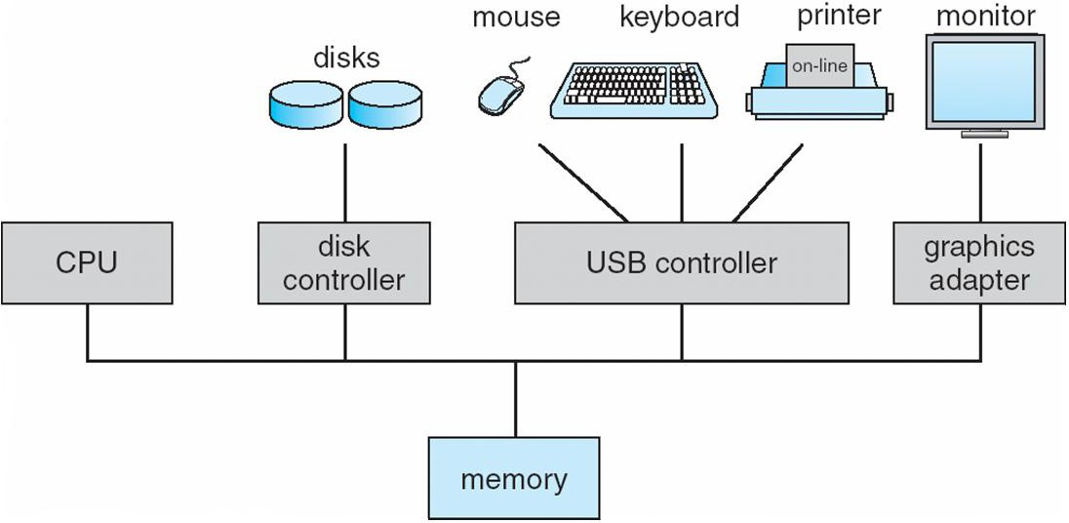

A modern general purpose computer has CPU and device controllers for devices such as disk, audio devices, and video display devices connected to a common system bus. Each controller is for a specific device only and it has a local buffer. The CPU and device controllers can run concurrently and compete for memory. A memory controller synchronizes access to shared memory. When a computer starts it initiates a simple program called the bootstrap program stored in a read-only memory (ROM) or erasable programmable read-only memory (EPROM). The bootstrap is a simple program that initiates the system and loads the OS in memory. The OS waits for an event called. Interrupt There are two types of interrupts – hardware and software interrupt. The hardware generates interrupt by signaling the CPU directly. A software interrupt is performed by a system call also known as monitor call. The CPU stops current operation and transfer the control to a fixed memory location where interrupt service routine (ISR) for the interrupt is located. Once interrupt service routine finished execution, the CPU resume the control of the interrupted operation.

Two things are very important, no matter how OS is designed:

- CPU must efficiently transfer the control to ISR.
- Speed up the process of transfer.

The ISR can call an interrupt handler to check the appropriate handler, but it is not necessary because there are few fixed addresses for ISRs. Hence, a table of pointers to the ISR address called is Interrupt vector maintained. The indexed interrupt vector immediately transfers the control to the correct ISR of a device upon receiving interrupt request. The interrupt mechanism must save the address of the interrupted instruction in a fixed memory location, or a stack and load this address to program counter once the interrupt routine is completed. This will appear as if the interrupt never happened.

Operating system can be implemented with the help of various structures. The structure of the OS depends mainly on how the various common components of the operating system are interconnected and melded into the kernel. Depending on this we have following structures of the operating system:

Simple structure:
Such operating systems do not have well defined structure and are small, simple and limited systems. The interfaces and levels of functionality are not well separated. MS-DOS is an example of such operating system. In MS-DOS application programs are able to access the basic I/O routines. These types of operating system cause the entire system to crash if one of the user programs fails.
Diagram of the structure of MS-DOS is shown below.

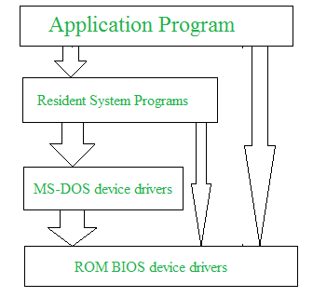

Advantages of Simple structure:

- It delivers better application performance because of the few interfaces between the application program and the hardware.
- Easy for kernel developers to develop such an operating system.

Disadvantages of Simple structure:
- The structure is very complicated as no clear boundaries exist between modules.
- It does not enforce data hiding in the operating system.
Layered structure:
An OS can be broken into pieces and retain much more control on system. In this structure the OS is broken into number of layers (levels). The bottom layer (layer 0) is the hardware and the topmost layer (layer N) is the user interface. These layers are so designed that each layer uses the functions of the lower level layers only. This simplifies the debugging process as if lower level layers are debugged and an error occurs during debugging then the error must be on that layer only as the lower level layers have already been debugged.

The main disadvantage of this structure is that at each layer, the data needs to be modified and passed on which adds overhead to the system. Moreover careful planning of the layers is necessary as a layer can use only lower level layers. UNIX is an example of this structure.

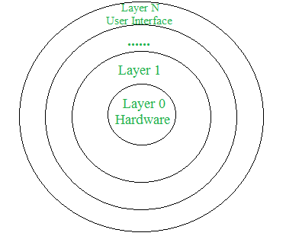

Advantages of Layered structure:
- Layering makes it easier to enhance the operating system as implementation of a layer can be changed easily without affecting the other layers.
- It is very easy to perform debugging and system verification.

Disadvantages of Layered structure:
- In this structure the application performance is degraded as compared to simple structure.
- It requires careful planning for designing the layers as higher layers use the functionalities of only the lower layers.

Micro-kernel:
This structure designs the operating system by removing all non-essential components from the kernel and implementing them as system and user programs. This result in a smaller kernel called the micro-kernel.
Advantages of this structure are that all new services need to be added to user space and does not require the kernel to be modified. Thus it is more secure and reliable as if a service fails then rest of the operating system remains untouched. Mac OS is an example of this type of OS.
Advantages of Micro-kernel structure:
- It makes the operating system portable to various platforms.
- As microkernel are small so these can be tested effectively.
Disadvantages of Micro-kernel structure:
- Increased level of inter module communication degrades system performance.

Modular structure or approach:
It is considered as the best approach for an OS. It involves designing of a modular kernel. The kernel has only set of core components and other services are added as dynamically loadable modules to the kernel either during run time or boot time. It resembles layered structure due to the fact that each kernel has defined and protected interfaces but it is more flexible than the layered structure as a module can call any other module.

For example Solaris OS is organized as shown in the figure.

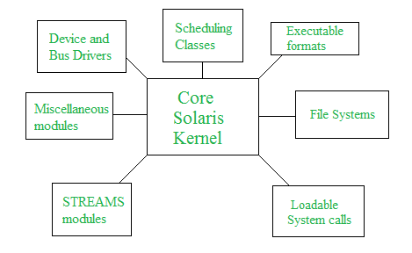

Computer-System Operation

I/O devices and the CPU can execute concurrently Each device controller is in charge of a particular device type Each device controller has a local buffer CPU moves data from/to main memory to/from local buffers I/O is from the device to local buffer of controller Device controller informs CPU that it has finished its operation by causing An interrupt

Dual-Mode Operation
In order to ensure the proper execution of the operating system, we must be able to distinguish between the execution of operating-system code and user defined code. The approach taken by most computer systems is to provide hardware support that allows us to differentiate among various modes of execution. At the very least, we need two separate modes of operation: user mode and kernel mode (also called supervisor mode, system mode, or privileged mode). A bit, called the mode bit, is added to the hardware of the computer to indicate the current mode: kernel (0) or user (1). With the mode bit, we are able to distinguish between a task that is executed on behalf of the operating system and one that is executed on behalf of the user.
When the computer system is executing on behalf of a user application, the system is in user mode. However, when a user application requests a service from the operating system (via a system call), it must transition from user to kernel mode to fulfill the request. As we shall see, this architectural enhancement is useful for many other aspects of system operation as well.

At system boot time, the hardware starts in kernel mode. The operating system is then loaded and starts user applications in user mode. Whenever a trap or interrupt occurs, the hardware switches from user mode to kernel mode (that is, changes the state of the mode bit to 0). Thus, whenever the operating system gains control of the computer, it is in kernel mode. The system always switches to user mode (by setting the mode bit to 1) before passing control to a user program.

Dual Mode operations in OS

An error in one program can adversely affect many processes, it might modify data of another program, or also can affect the operating system. For example, if a process stuck in the infinite loop then this infinite loop could affect the correct operation of other processes. So to ensure the proper execution of the operating system,

There are two modes of operation:
User mode –
When the computer system is run by user applications like creating a text document or using any application program, then the system is in user mode. When the user application requests for a service from the operating system or an interrupt occurs or system calls, then there will be a transition from user to kernel mode to fulfill the requests.
Note: To switch from kernel mode to user mode, the mode bit should be 1.
Given below image describes what happen when an interrupt occurs:

Kernel Mode –
When the system boots, hardware starts in kernel mode and when the operating system is loaded, it starts user application in user mode. To provide protection to the hardware, we have privileged instructions which execute only in kernel mode. If the user attempts to run privileged instruction in user mode then it will treat instruction as illegal and traps to OS. Some of the

Privileged instructions are:

- Handling Interrupts
- To switch from user mode to kernel mode.
- Input-Output management.

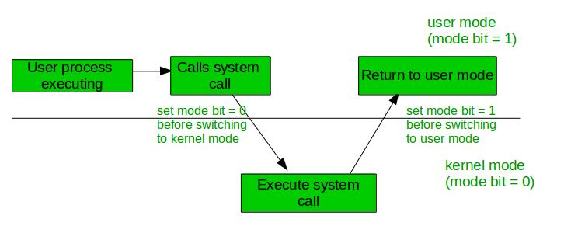

Common Functions of Interrupts

Interrupt transfers control to the interrupt service routine generally, through the interrupt vector, which contains the addresses of all the service routines Interrupt architecture must save the address of the interrupted instruction Incoming interrupts are disabled while another interrupt is being processed to prevent a lost interruptnA trap is a software-generated interrupt caused either by an error or a user request An operating system is interrupt driven Interrupt Handling The operating system preserves the state of the CPU by storing registers and the program counter

Determines which type of interrupt has occurred Polling vectored interrupt system Separate segments of code determine what action should be taken for each type of interrupt

Interrupt Timeline

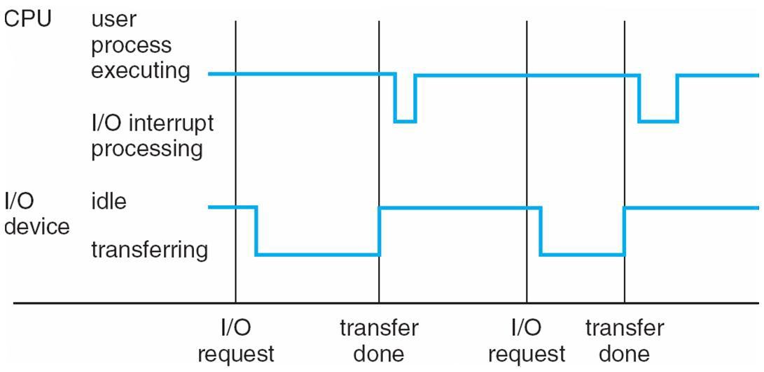

OPERATING SYSTEM FUNCTIONS

Process Management

Program vs Process

A process is a program in execution. For example, when we write a program in C or C++ and compile it, the compiler creates binary code. The original code and binary code are both programs. When we actually run the binary code, it becomes a process.

A process is an ‘active’ entity, instead of a program, which is considered a ‘passive’ entity. A single program can create many processes when run multiple times; for example, when we open a .exe or binary file multiple times, multiple instances begin (multiple processes are created).
A process is a program in execution. It is a unit of work within the system. Program is a passive entity, process is an active entity.
- Process needs certain resources, including CPU time, memory, I/O files to accomplish it task.
- Initialization data
- Process termination requires reclaim of any reusable resources
- Single-threaded process has one program counter specifying location of next instruction to execute Process executes instructions sequentially, one at a time, until completion
- Multi-threaded process has one program counter per thread
- Typically system has many processes, some user, some operating system running concurrently on one or more CPUs
- Concurrency by multiplexing the CPUs among the processes / threads

Process Management Activities

The operating system is responsible for the following activities in connection with process management:

- Creating and deleting both user and system processes
- Suspending and resuming processes
- Providing mechanisms for process synchronization
- Providing mechanisms for process communication
- Providing mechanisms for deadlock handling

Memory Management

The term Memory can be defined as a collection of data in a specific format. It is used to store instructions and processed data. The memory comprises a large array or group of words or bytes, each with its own location. The primary motive of a computer system is to execute programs. These programs, along with the information they access, should be in the main memory during execution. The CPU fetches instructions from memory according to the value of the program counter.
To achieve a degree of multiprogramming and proper utilization of memory, memory management is important. Many memory management methods exist, reflecting various approaches, and the effectiveness of each algorithm depends on the situation.

Main Memory:
The main memory is central to the operation of a modern computer. Main Memory is a large array of words or bytes, ranging in size from hundreds of thousands to billions. Main memory is a repository of rapidly available information shared by the CPU and I/O devices. Main memory is the place where programs and information are kept when the processor is effectively utilizing them. Main memory is associated with the processor, so moving instructions and information into and out of the processor is extremely fast. Main memory is also known as RAM(Random Access Memory). This memory is a volatile memory.RAM lost its data when a power interruption occurs.

Memory Management :
In a multiprogramming computer, the operating system resides in a part of memory and the rest is used by multiple processes. The task of subdividing the memory among different processes is called memory management. Memory management is a method in the operating system to manage operations between main memory and disk during process execution. The main aim of memory management is to achieve efficient utilization of memory.

Why Memory Management is required:
- Allocate and de-allocate memory before and after process execution.
- To keep track of used memory space by processes.
- To minimize fragmentation issues.
- To proper utilization of main memory.
- To maintain data integrity while executing of process.

All data in memory before and after processing All instructions in memory in order to execute
Memory management determines what is in memory when Optimizing CPU utilization and computer response to users

Memory management activities

- Keeping track of which parts of memory are currently being used and by whom
- Deciding which processes (or parts thereof) and data to move into and out of memory
- Allocating and deallocating memory space as needed

Storage Management

Storage Management is defined as it refers to the management of the data storage equipment’s that are used to store the user/computer generated data. Hence it is a tool or set of processes used by an administrator to keep your data and storage equipment’s safe.
Storage management is a process for users to optimize the use of storage devices and to protect the integrity of data for any media on which it resides and the category of storage management generally contain the different type of subcategories covering aspects such as security, virtualization and more, as well as different types of provisioning or automation, which is generally made up the entire storage management software market.

Storage management key attributes:
Storage management has some key attribute which is generally used to manage the storage capacity of the system. These are given below:
1. Performance
2. Reliability
3. Recoverability
4. Capacity
Feature of Storage management:
There is some feature of storage management which is provided for storage capacity. These are given below:
- Storage management is a process that is used to optimize the use of storage devices.
- Storage management must be allocated and managed as a resource in order to truly benefit a corporation.
- Storage management is generally a basic system component of information systems.
- It is used to improve the performance of their data storage resources.

Advantage of storage management:
There are some advantage of storage management which are given below:
- It is very simple to managed a storage capacity.
- It is generally take a less time.
- It is improve the performance of system.
- In virtualization and automation technologies can help an organization improve its agility.

OS provides uniform, logical view of information storage Abstracts physical properties to logical storage unit
file
Each medium is controlled by device (i.e., disk drive, tape drive). Varying properties include access speed, capacity, data-transfer rate, access method (sequential or random)

File-System management

Files usually organized into directories Access control on most systems to determine who can access what

OS activities include Creating and deleting files and directories Primitives to manipulate files and dirs Mapping files onto secondary storage Backup files onto stable (non-volatile) storage media

Mass-Storage Management

Usually disks used to store data that does not fit in main memory or data that must be kept for a “long” period of time Proper management is of central importance Entire speed of computer operation hinges on disk subsystem and its algorithms

Mass Storage Activities
- Free-space management Storage allocation
- Disk scheduling
- Some storage need not be fast
- Tertiary storage includes optical storage, magnetic tape Still must be managed
- Varies between WORM (write-once, read-many-times) and RW (read-write)

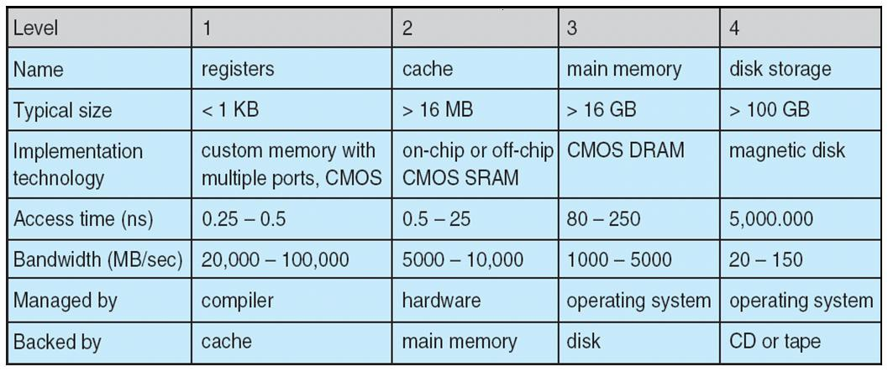
Performance of Various Levels of Storage

Migration of Integer A from Disk to Register

 Multitasking environments must be careful to use most recent value, no matter where it is stored in the storage hierarchy
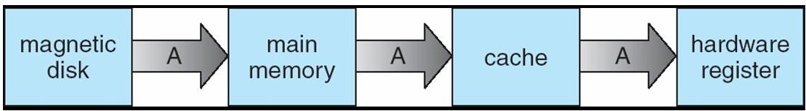

Multiprocessor environment must provide cache coherency in hardware such that all CPUs have the most recent value in their cache
Distributed environment situation even more complex Several copies of a datum can exist

I/O Subsystem
One purpose of OS is to hide peculiarities of hardware devices from the user I/O subsystem responsible for
Memory management of I/O including buffering (storing data temporarily while it is being transferred), caching (storing parts of data in faster storage for performance), spooling (the overlapping of output of one job with input of other jobs)
General device-driver interface Drivers for specific hardware devices

Protection and Security

Protection – any mechanism for controlling access of processes or users to resources defined by the OS

Security – defense of the system against internal and external attacks.

Huge range, including denial-of-service, worms, viruses, identity theft, theft of service Systems generally first distinguish among users, to determine who can do what User identities (user IDs, security IDs) include name and associated number, one per user User ID then associated with all files, processes of that user to determine access control Group identifier (group ID) allows set of users to be defined and controls managed, then also associated with each process, file Privilege escalation allows user to change to effective ID with more rights

Security:
The security systems covers the safety of their system resources (saved data, memory, disks, etc) across malignant alteration, illegal access, and disparity or inconsistency. The security gives a mechanism (authentication and encryption) to analyze the user to permit for using the system.

For example, in a corporation that the info is obtained by completely different workers however, it can’t be obtained by a user that doesn’t exist in this explicit organization or a user operating in different business enterprises. Security is the vital task for a corporation to provide some safety mechanism in order that no outside user will access the knowledge of the organization.
Protection:
protection deals with the access to the system resources. It determines that what files can be accessed or permeated by a special user. The protection of the system should confirm the approval of the process and users. Due to this, these licensed users and processes will care for the central processing unit, memory and alternative sources. The protection mechanism ought to provide a path for specifying the controls to be obligatory, beside how of implementing them.
Example of protection can be given from the security, any organization will have many departments below that several staff operate. the assorted departments will share frequent info with one another however not sensitive info. So, completely different employees have different access rights the info in step with that they will access the define data.

Let’s see the difference between security and protection:

1. | Basic | Security grants the system access to the appropriate users only. | While protection deals with the access to the system resources.
2. | Type of threats involved of the system | In security, external threats are involved. | While in protection, internal threats are involved.
3. | Queries handle | In security, more convoluted queries are handled. | Whereas in protection, simple queries are handled.
4. | Policy | Security illustrates that which person is granted for using the system. | Whereas protection determines that what files can be accessed or permeated by a special user.
5. | Mechanism | In security, encryption and certification(authentication) mechanisms are used. | Whereas in protection, authorization mechanism is implemented.

Computing Environments
In the world of technology where every tasks are performed with help of computers, these computers have become one part of human life. Computing is nothing but process of completing a task by using this computer technology and it may involve computer hardware and/or software. But computing uses some form of computer system to manage, process, and communicate information. After getting some idea about computing now lets understand about computing environments.

Computing Environments :
When a problem is solved by the computer, during that computer uses many devices, arranged in different ways and which work together to solve problems. This constitutes a computing environment where various number of computer devices arranged in different ways to solve different types of problems in different ways. In different computing environments computer devices are arranged in different ways and they exchange information in between them to process and solve problem. One computing environment consists of many computers other computational devices, software and networks that to support processing and sharing information and solving task.

Based on the organization of different computer devices and communication processes there exists multiple types of computing environments. Now lets know about different types of computing environments.

- Traditional computer
- Blurring over time.
- Office environment
PCs connected to a network, terminals attached to mainframe or minicomputers providing batch and timesharing
Now portals allowing networked and remote systems access to same resources .
- Home networks
Used to be single system, then modems
Now firewalled, networked
- Client-Server Computing

- Dumb terminals supplanted by smart PCs
- Many systems now servers, responding to requests generated by clients
Compute-server provides an interface to client to request services (i.e. database)
File-server provides interface for clients to store and retrieve files
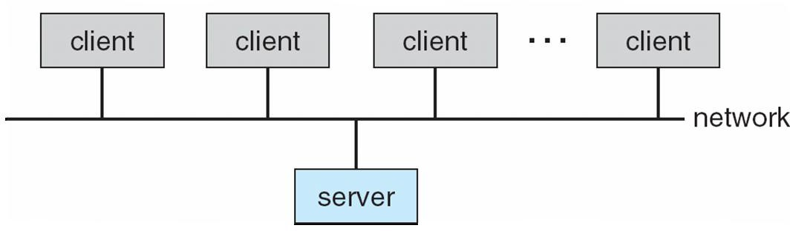

Peer-to-Peer Computing

- Another model of distributed system
- P2P does not distinguish clients and servers Instead all nodes are considered peers
- May each act as client, server or both Node must join P2P network
Registers its service with central lookup service on network, or
Broadcast request for service and respond to requests for service via discovery protocol
- Examples include Napster and Gnutella

Web-Based Computing

- Web has become ubiquitous PCs most prevalent devices
- More devices becoming networked to allow web access
- New category of devices to manage web traffic among similar servers: load balancers
- Use of operating systems like Windows 95, client-side, have evolved into Linux and Windows XP, which can be clients and servers

Open-Source Operating Systems

- Operating systems made available in source-code format rather than just binary closed-source
- Counter to the copy protection and Digital Rights Management (DRM) movement
- Started by Free Software Foundation (FSF), which has “copyleft” GNU Public License (GPL)
- Examples include GNU/Linux, BSD UNIX (including core of Mac OS X), and Sun Solaris

- Personal Computing Environment :
In personal computing environment there is a stand-alone machine. Complete program resides on computer and executed there. Different stand-alone machines that constitute a personal computing environment are laptops, mobiles, printers, computer systems, scanners etc. That we use at our homes and offices.

- Time-Sharing Computing Environment :
In Time Sharing Computing Environment multiple users share system simultaneously. Different users (different processes) are allotted different time slice and processor switches rapidly among users according to it. For example, student listening to music while coding something in an IDE. Windows 95 and later versions, Unix, IOS, Linux operating systems are the examples of this time sharing computing environment.
- Client Server Computing Environment :
In client server computing environment two machines are involved i.e., client machine and server machine, sometime same machine also serve as client and server. In this computing environment client requests resource/service and server provides that respective resource/service. A server can provide service to multiple clients at a time and here mainly communication happens through computer network.

- Distributed Computing Environment :
In a distributed computing environment multiple nodes are connected together using network but physically they are separated. A single task is performed by different functional units of different nodes of distributed unit. Here different programs of an application run simultaneously on different nodes, and communication happens in between different nodes of this system over network to solve task.

- Grid Computing Environment :
In grid computing environment, multiple computers from different locations works on single problem. In this system set of computer nodes running in cluster jointly perform a given task by applying resources of multiple computers/nodes. It is network of computing environment where several scattered resources provide running environment for single task.

- Cloud Computing Environment :
In cloud computing environment on demand availability of computer system resources like processing and storage are availed. Here computing is not done in individual technology or computer rather it is computed in cloud of computers where all required resources are provided by cloud vendor. This environment primarily comprised of three services i.e software-as-a-service (SaaS), infrastructure-as-a-service (IaaS), and platform-as-a-service (PaaS).

- Cluster Computing Environment :
In cluster computing environment cluster performs task where cluster is a set of loosely or tightly connected computers that work together. It is viewed as single system and performs task parallelly that’s why also it is similar to parallel computing environment. Cluster aware applications are especially used in cluster computing environment.

Operating System Services

One set of operating-system services provides functions that are helpful to the user:
- User interface - Almost all operating systems have a user interface (UI)
Varies between Command-Line (CLI), Graphics User Interface (GUI), Batch
- Program execution - The system must be able to load a program into memory and to run that program, end execution, either normally or abnormally (indicating error)
- I/O operations - A running program may require I/O, which may involve a file or an I/O device
- File-system manipulation - The file system is of particular interest. Obviously, programs need to read and write files and directories, create and delete them, search them, list file Information, permission management.

A View of Operating System Services
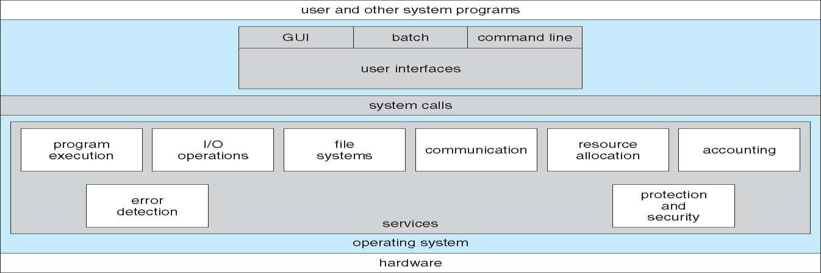
Operating System Services
One set of operating-system services provides functions that are helpful to the user.

- Communications – Processes may exchange information, on the same computer or between computers over a network Communications may be via shared memory or through message passing (packets moved by the OS)
- Error detection – OS needs to be constantly aware of possible errors May occur in the CPU and memory hardware, in I/O devices, in user program For each type of error, OS should take the appropriate action to ensure correct and consistent computing Debugging facilities can greatly enhance the user’s and programmer’s abilities to efficiently use the system

Another set of OS functions exists for ensuring the efficient operation of the system itself via resource sharing
- Resource allocation - When multiple users or multiple jobs running concurrently, resources must be allocated to each of them, Many types of resources - Some (such as CPU cycles, main memory, and file storage) may have special allocation code, others (such as I/O devices) may have general request and release code
- Accounting - To keep track of which users use how much and what kinds of computer resources
- Protection and security - The owners of information stored in a multiuser or networked computer system may want to control use of that information, concurrent processes should not interfere with each other
- Protection involves ensuring that all access to system resources is controlled
- Security of the system from outsiders requires user authentication, extends to defending external I/O devices from invalid access attempts
- If a system is to be protected and secure, precautions must be instituted throughout it. A chain is only as strong as its weakest link.

User Operating System Interface –

USER INTERFACES
A user interface (UI) refers to the part of an operating system, program, or device that allows a user to enter and receive information. A text-based user interface (see the image to the left) displays text, and its commands are usually typed on a command line using a keyboard. With a graphical user interface (see the right-hand image), the functions are carried out by clicking or moving buttons, icons and menus by means of a pointing device.

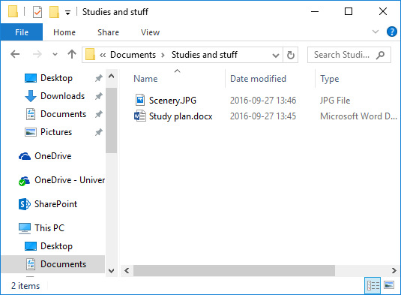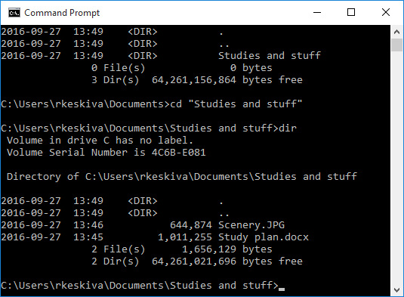

Larger image: text UI | graphical UI
The images contain the same information: a directory listing of a computer. You can often carry out the same tasks regardless of which kind of UI you are using.

TEXT USER INTERFACE (TUI)
Modern graphical user interfaces have evolved from text-based UIs. Some operating systems can still be used with a text-based user interface. In this case, the commands are entered as text (e.g., “cat story.txt”).

GRAPHICAL USER INTERFACE

In most operating systems, the primary user interface is graphical, i.e. instead of typing the commands you manipulate various graphical objects (such as icons) with a pointing device. The underlying principle of different graphical user interfaces (GUIs) is largely the same, so by knowing how to use a Windows UI, you will most likely know how to use Linux or some other GUI.
Most GUIs have the following basic components:
- a start menu with program groups
- a taskbar showing running programs
- a desktop
- various icons and shortcuts.

CLI Command Line Interface (CLI)

command interpreter allows direct command entry Sometimes implemented in kernel, sometimes by systems program Sometimes multiple flavors implemented – shells Primarily fetches a command from user and executes it Sometimes commands built-in, sometimes just names of programs If the latter, adding new features doesn’t require shell modification

User Operating System Interface – GUI

User-friendly desktop metaphor interface Usually mouse, keyboard, and monitor Icons represent files, programs, actions, etc

Various mouse buttons over objects in the interface cause various actions (provide information, options, execute function, open directory (known as a folder)

Invented at Xerox PARC
Many systems now include both CLI and GUI interfaces Microsoft Windows is GUI with CLI “command” shell
Apple Mac OS X as “Aqua” GUI interface with UNIX kernel underneath and shells available Solaris is CLI with optional GUI interfaces (Java Desktop, KDE)

Bourne Shell Command Interpreter
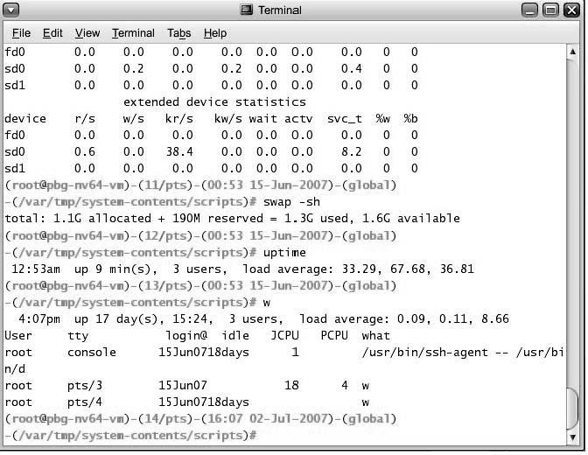

The Mac OS X GUI
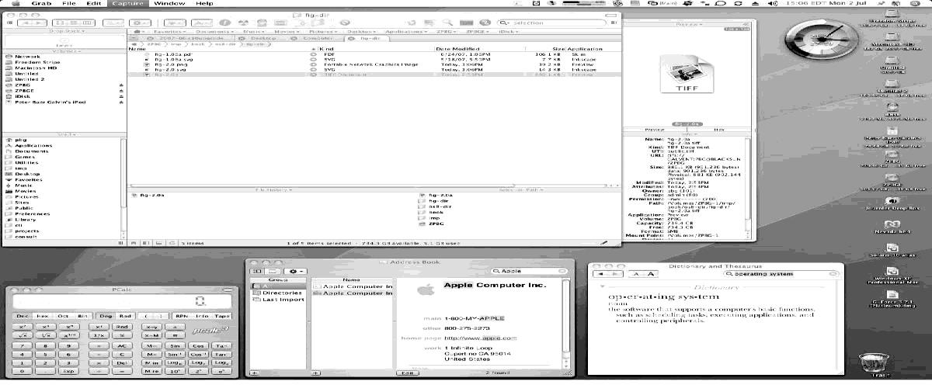

System Calls


Programming interface to the services provided by the OS Typically written in a high-level language (C or C++)
Mostly accessed by programs via a high-level Application Program Interface (API) rather than direct system call usenThree most common APIs are Win32 API for Windows, POSIX API for POSIX-based systems (including virtually all versions of UNIX, Linux, and Mac OS X), and Java API for the Java virtual machine (JVM)
Why use APIs rather than system calls?(Note that the system-call names used throughout this text are generic)

Example of System Calls
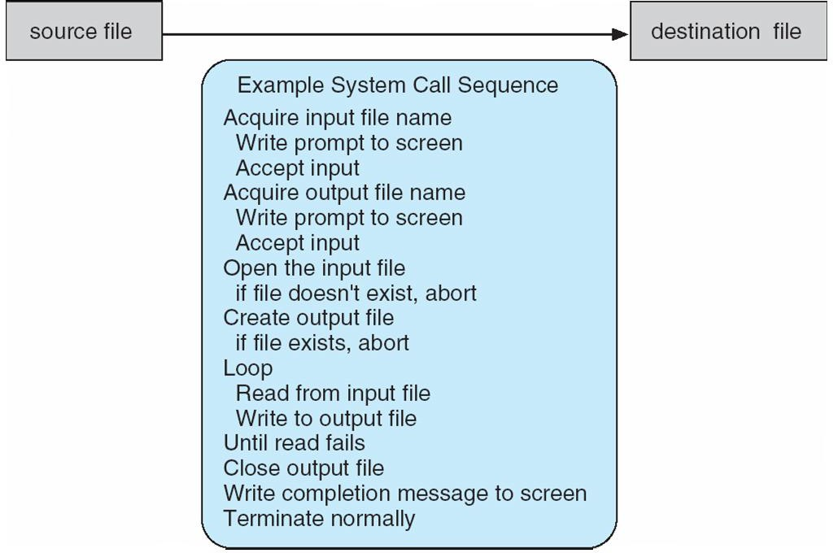

Example of Standard API
Consider the ReadFile() function in the
Win32 API—a function for reading from a file

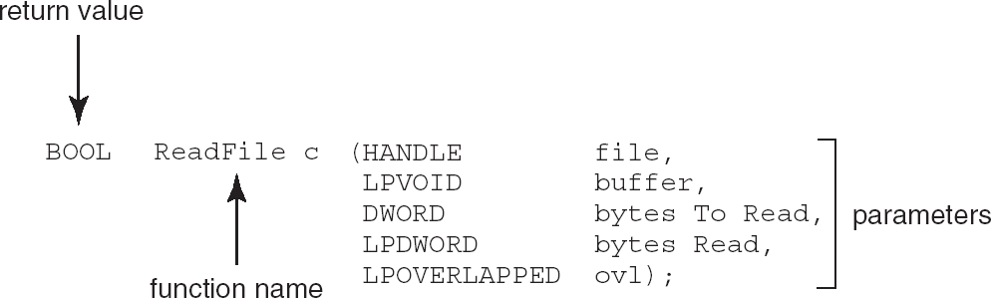


A description of the parameters passed to ReadFile() HANDLE file—the file to be read
LPVOID buffer—a buffer where the data will be read into and written from DWORD bytesToRead—the number of bytes to be read into the buffer LPDWORD bytesRead—the number of bytes read during the last read LPOVERLAPPED ovl—indicates if overlapped I/O is being used


System Call Implementation
Typically, a number associated with each system call
System-call interface maintains a table indexed according to these Numbers
The system call interface invokes intended system call in OS kernel and returns status of the system call and any return values
The caller need know nothing about how the system call is implemented Just needs to obey API and understand what OS will do as a result call Most details of OS interface hidden from programmer by API
Managed by run-time support library (set of functions built into libraries included with compiler)

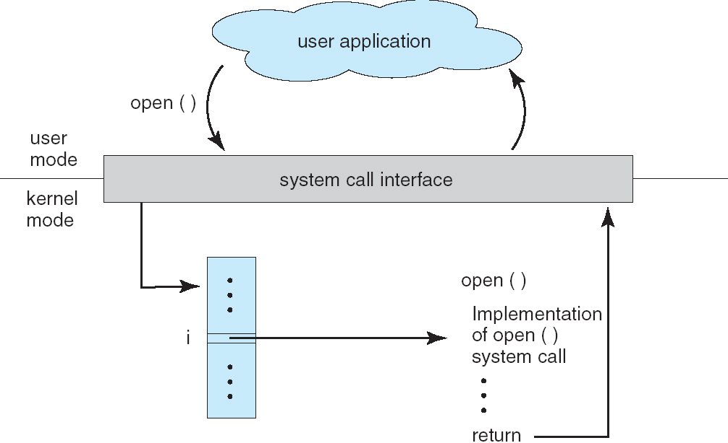
API – System Call – OS Relationship

Standard C Library Example
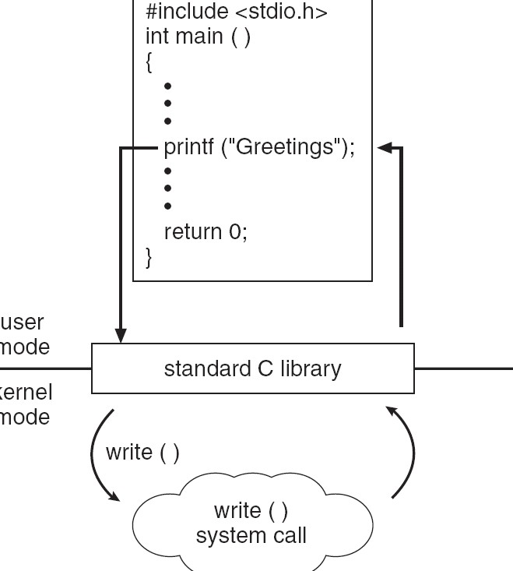

System Call Parameter Passing
Often, more information is required than simply identity of desired system call Exact type and amount of information vary according to OS and call
Three general methods used to pass parameters to the OS Simplest: pass the parameters in registers
 In some cases, may be more parameters than registers
Parameters stored in a block, or table, in memory, and address of block passed as a parameter in a register
This approach taken by Linux and Solaris
Parameters placed, or pushed, onto the stack by the program and popped off the stack by the operating system
Block and stack methods do not limit the number or length of parameters being passed

Parameter Passing via Table

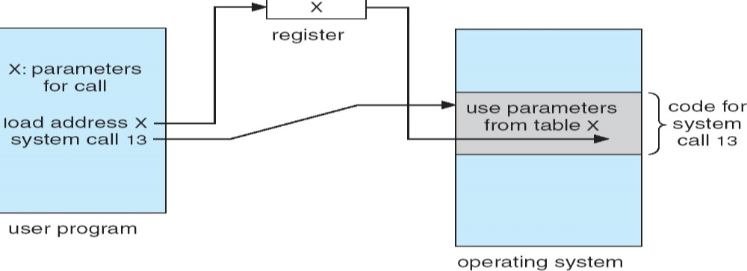


Types of System Calls
Process control File management
Device management Information maintenance Communications Protection

Examples of Windows and Unix System Calls
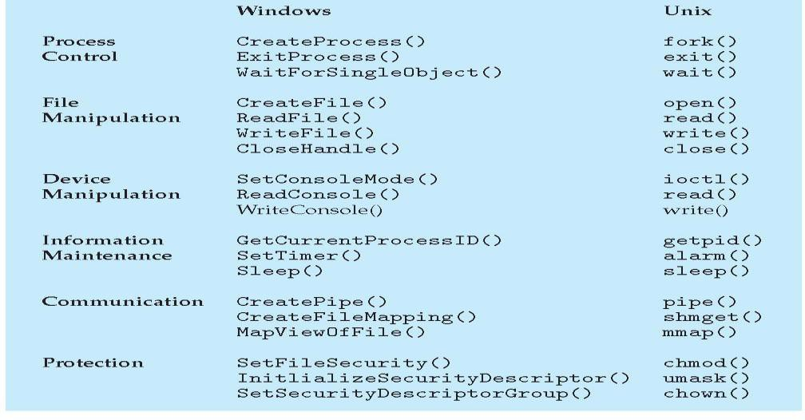
MS-DOS execution
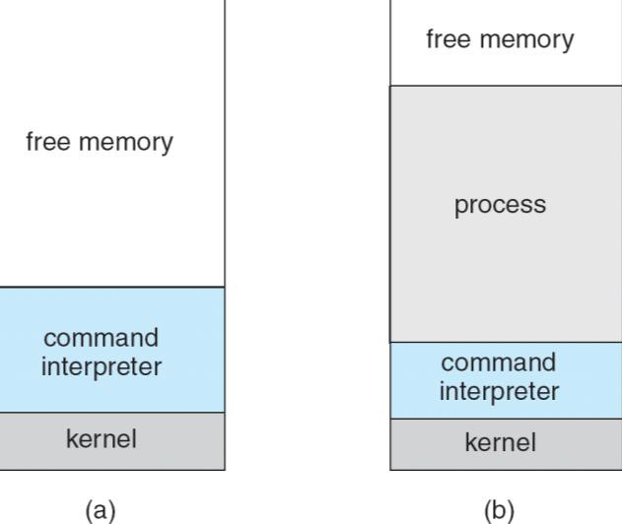
(a) At system startup (b) running a program

FreeBSD Running Multiple Programs
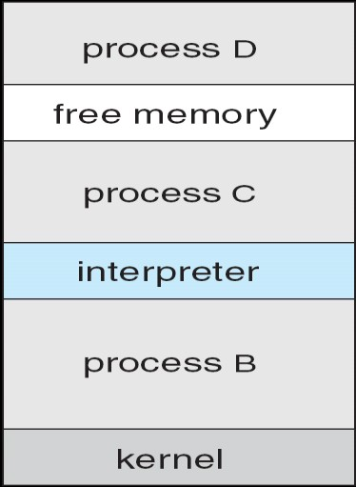

System Programs

System programs provide a convenient environment for program development and execution. The can be divided into:
File manipulation Status information File modification
Programming language support Program loading and execution Communications
Application programs
Most users’ view of the operation system is defined by system programs, not the actual system calls Provide a convenient environment for program development and execution
Some of them are simply user interfaces to system calls; others are considerably more complex

File management - Create, delete, copy, rename, print, dump, list, and generally manipulate files and directories
Status information
Some ask the system for info - date, time, amount of available memory, disk space, number of users Others provide detailed performance, logging, and debugging information
Typically, these programs format and print the output to the terminal or other output devices Some systems implement a registry - used to store and retrieve configuration information

File modification
Text editors to create and modify files
Special commands to search contents of files or perform transformations of the text Programming-language support - Compilers, assemblers, debuggers and interpreters sometimes provided
Program loading and execution- Absolute loaders, relocatable loaders, linkage editors, and overlay- loaders, debugging systems for higher-level and machine language

Communications - Provide the mechanism for creating virtual connections among processes, users, and computer systems
Allow users to send messages to one another’s screens, browse web pages, send electronic-mail messages, log in remotely, transfer files from one machine to another


Operating System Design and Implementation
Design and Implementation of OS not “solvable”, but some approaches have proven successful Internal structure of different Operating Systems can vary widely
Start by defining goals and specifications Affected by choice of hardware, type of system User goals and System goals
User goals – operating system should be convenient to use, easy to learn, reliable, safe, and fast

System goals – operating system should be easy to design, implement, and maintain, as well as flexible, reliable, error-free, and efficient
Important principle to separate Policy: What will be done? Mechanism: How to do it?
Mechanisms determine how to do something, policies decide what will be done
The separation of policy from mechanism is a very important principle, it allows maximum flexibility if policy decisions are to be changed later

